1.A company manufactures LED bulbs with a faulty rate of 30%. If I randomly select 6 chosen LEDs, what is the probability of having 2 faulty LEDs in my sample? Calculate the average value of this process. Also evaluate the standard deviation associated with it.

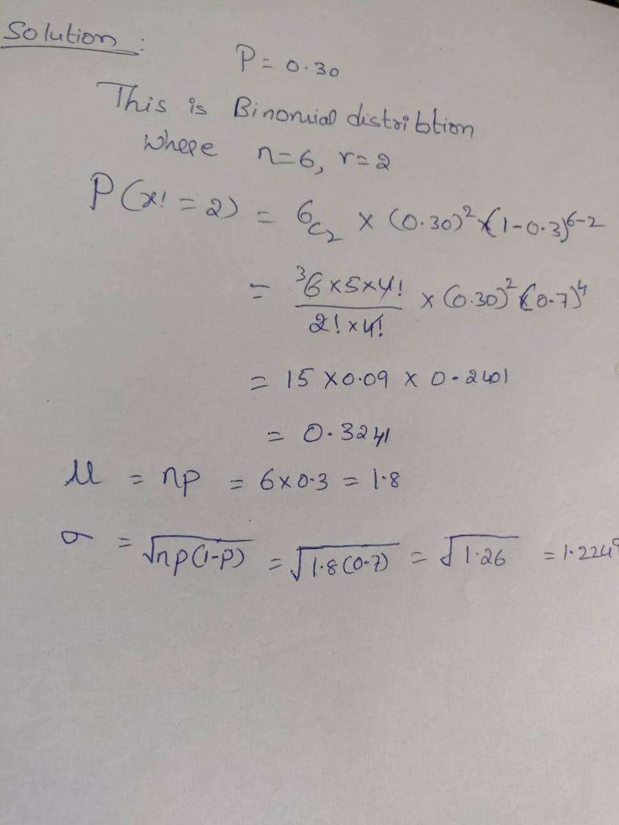

2.Gaurav and Barakha are both preparing for entrance exams. Gaurav attempts to solve 8 questions per day with a correction rate of 75%, while Barakha averages around 12 questions per day with a correction rate of 45%. What is the probability that each of them will solve 5 questions correctly? What happens in cases of 4 and 6 correct solutions? What do you infer from it? What are the two main governing factors affecting their ability to solve questions correctly? Give a pictorial representation of the same to validate your answer.

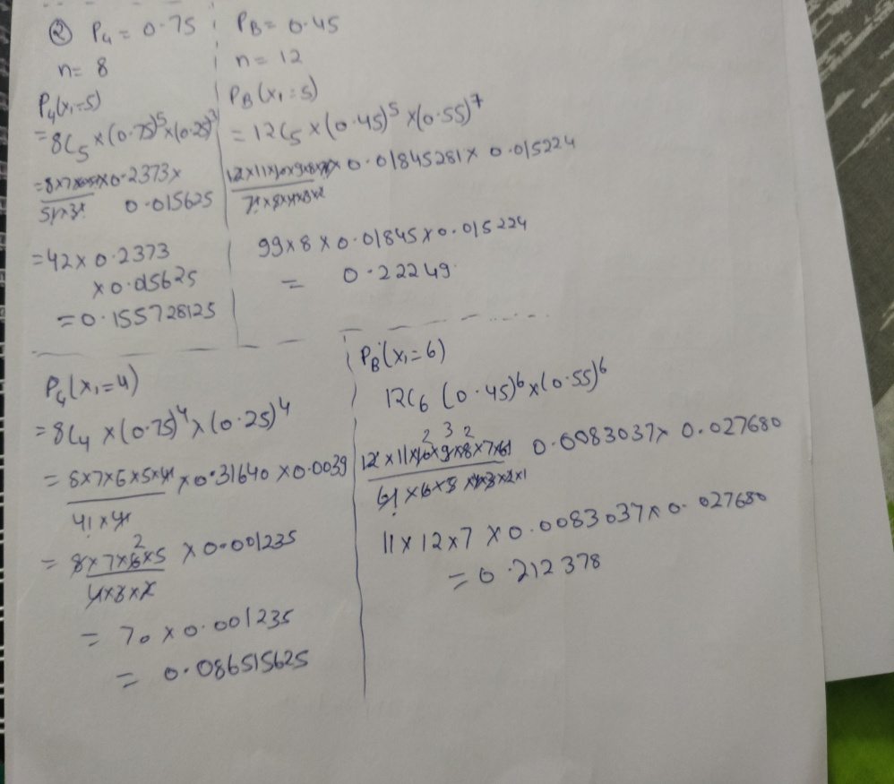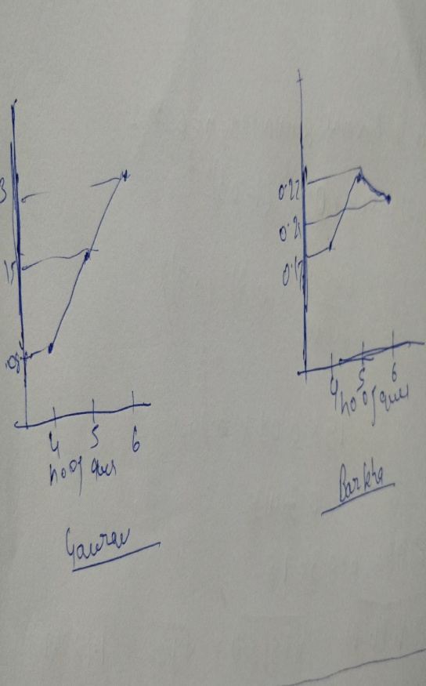

3.Customers arrive at a rate of 72 per hour to my shop. What is the probability of k customers arriving in 4 minutes? a) 5 customers, b) not more than 3 customers, c) more than 3 customers. Give a pictorial representation of the same to validate your answer.

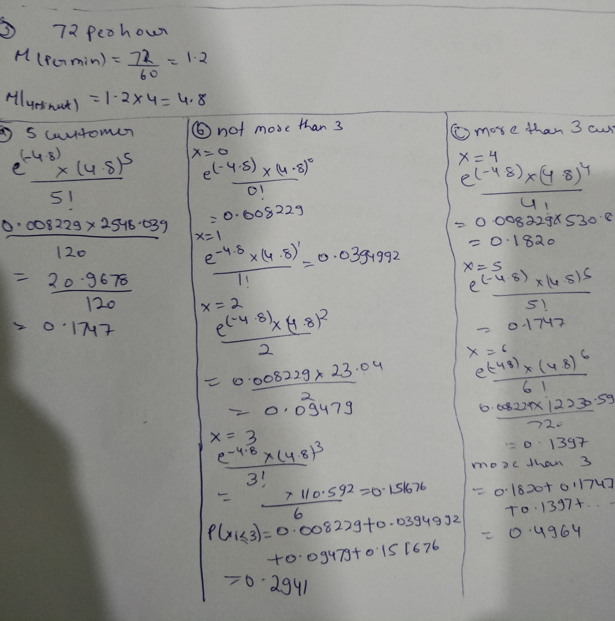

**4.**I work as a data analyst in Aeon Learning Pvt. Ltd. After analyzing data, I make reports, where I have the efficiency of entering 77 words per minute with 6 errors per hour. What is the probability that I will commit 2 errors in a 455-word financial report?

What happens when the no. of words increases (in case of 1000 words) or decreases (255 words)? How is the λ affected? How does it influence the PMF? Give a pictorial representation of the same to validate your answer.

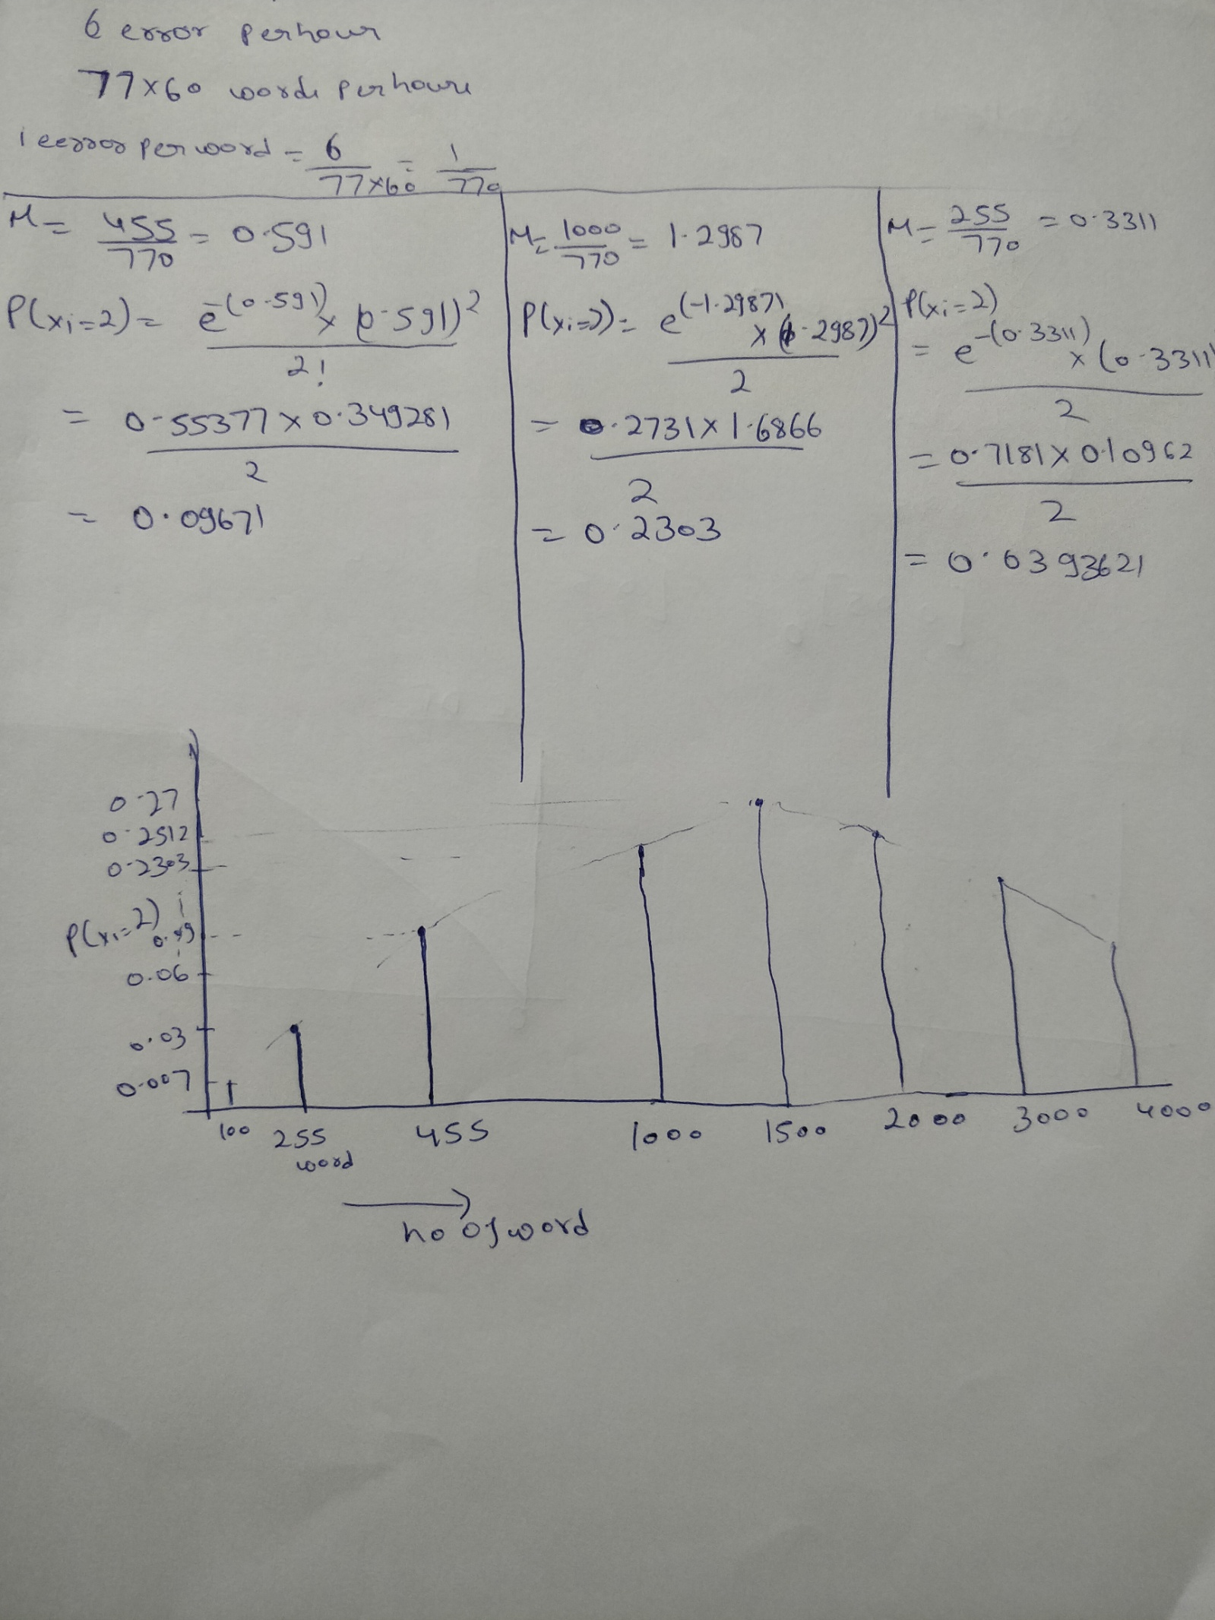

5.The current measured in a copper wire is modelled by a continuous random variable 𝑋. 𝑋 is in milliamperes. Assume that the range of *X* is [0, 20 mA]. The probability density function is given by, 𝑓(𝑥) = 0.05 for 0≤𝑥≤20. What is the probability that a current measurement is less than 10 milliamperes? Draw the PDF and the CDF diagrams as well.

